 **MUTHAYAMMAL COLLEGE OF ENGINEERING**

**(Approved by AICTE, New Delhi & Affiliated to Anna University)**

**Rasipuram - 637 408, Namakkal Dist.**

**Department of Science and Humanities**

**Event Photo**

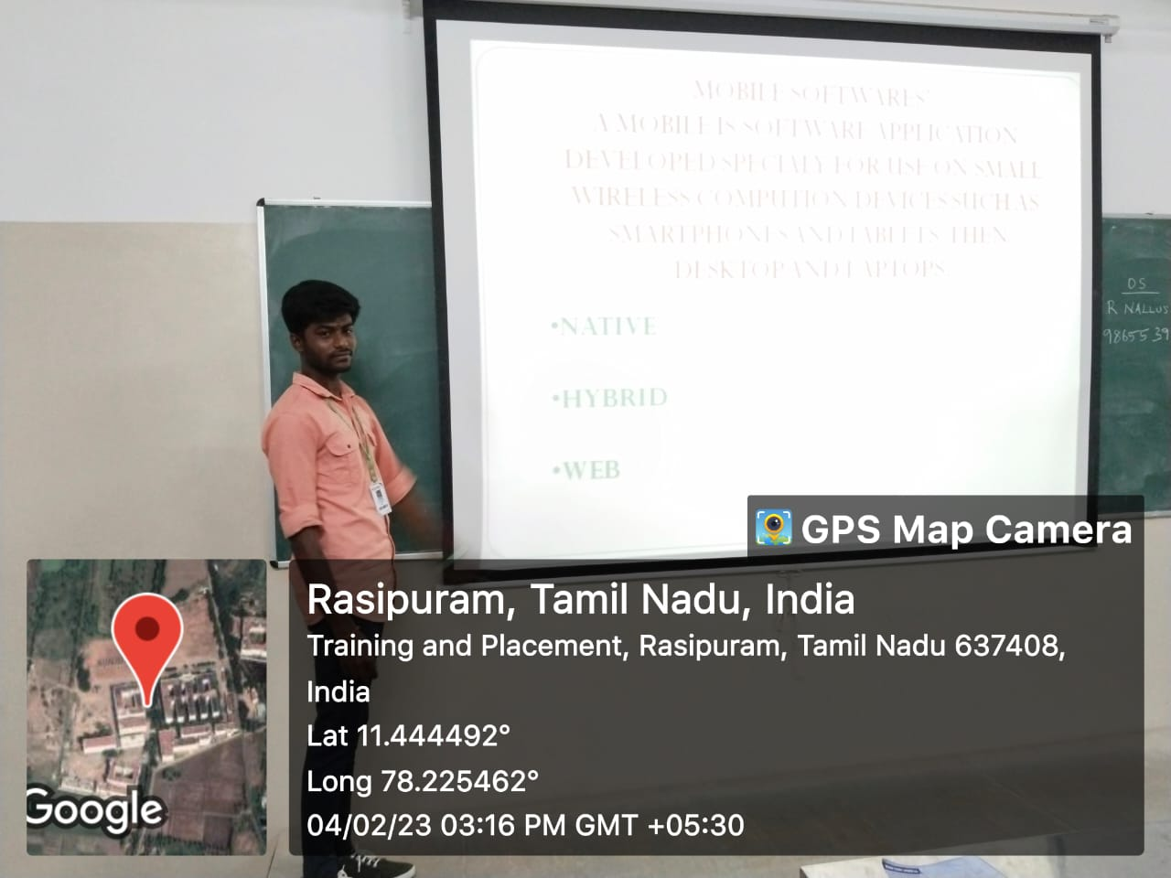 

**Signature of the Event Coordinators HoD(S&H) Principal**